Flocknote Templates for CDA
- Log in to your flocknote account, and click on your parish (if necessary).
- On your main dashboard, click “Check out the Library” on the right

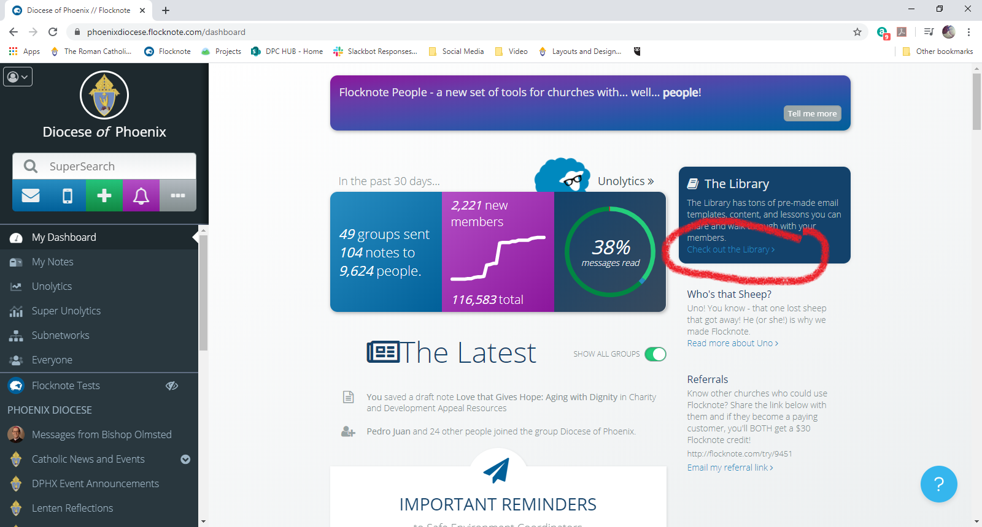

- Scroll through the library to find “Charity and Development Appeal Resources” from the Diocese of Phoenix.

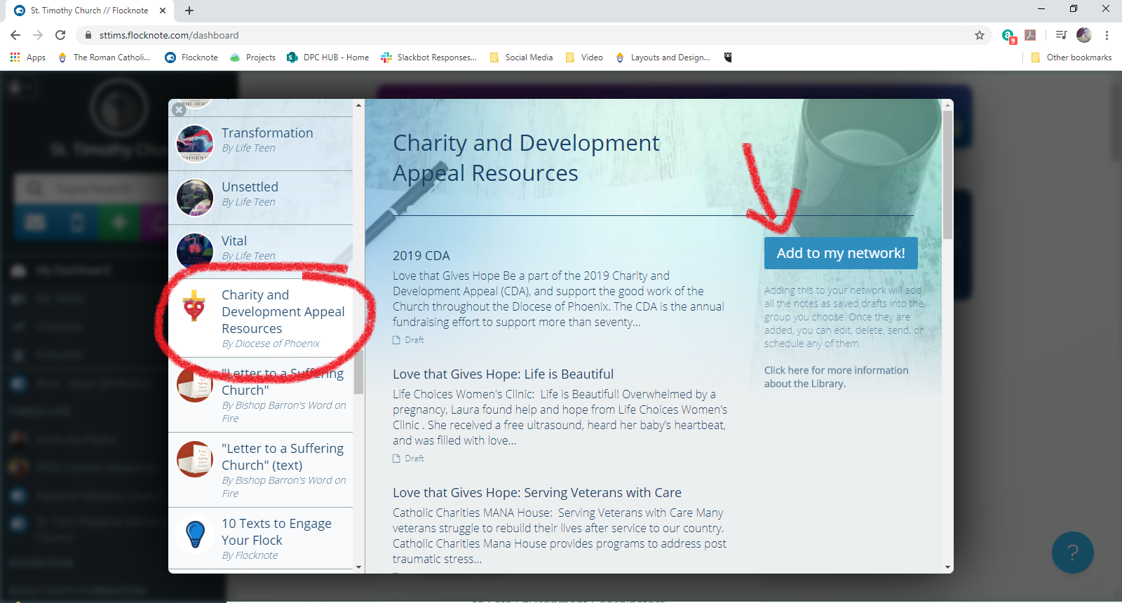

- Copy an individual note or add the whole series to your network in a group of your choosing.
- Customize and send!

