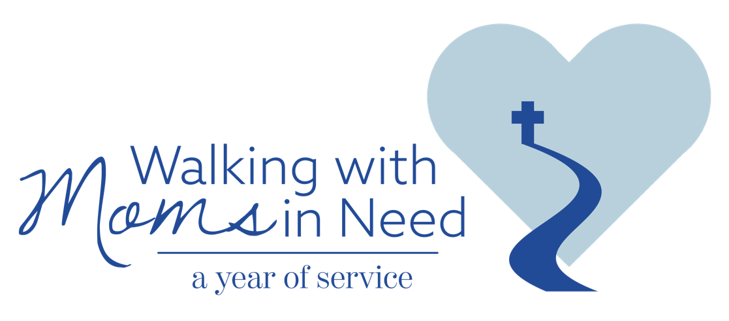

Inventory of Local Pregnancy Help Resources
for the Parish of

As part of the nationwide initiative to walk with moms in need, our parish is being asked to identify the local pregnancy help resources in our community that are currently available to a woman facing a difficult pregnancy. The needs of pregnant and parenting moms can be overwhelming, and the sources for help may not be apparent to those most needing support.

This inventory tool helps parish leaders identify local resources for pregnancy assistance such as pregnancy help centers, maternity homes, social service agencies, hospitals, and especially Catholic programs and resources. Detailed instructions for completing the inventory are available online. (A Parish Action Guide is also available to help guide parishes through the Year of Service.)

Our parish efforts to document and share local resources can make all the difference in the world for a pregnant woman and her child.
Note:
Please be sure to communicate with the diocesan contact person for the Year of Service before beginning this inventory. The diocesan contact can let you know of pregnancy help resources that have already been identified at the diocesan/regional level. These agencies and programs may have a local presence, and they may be helpful partners as parish leaders complete this inventory. The diocesan contact person may also be able to put you in touch with nearby parishes or offer cautions about external programs that may provide morally problematic services.
Parish Name:

Parish Address:

Pastor Name:

Name of parish contact person completing inventory:

Contact person’s role in the Parish:

Contact person’s phone:

Contact person’s email:

Additional team members assisting with the inventory:

Pregnancy  Help-Related Resources | Yes/No | Resource Name  & Address | Resource Website | Contact Person Name & Contact Info | List of Services  Provided | Comments
Pregnancy Help Centers,
such as Heartbeat, Birthright, Care Net, or independent centers, providing pregnancy testing, direct help and/or referrals

Mobile Ultrasound Unit
Private Medical Practices offering Prenatal, Ob-Gyn, Birthing and/or Post-Partum Care

Catholic Hospitals and Clinics

Community Hospitals and Health Centers

Birthing Centers
Maternity Homes (short/long term housing)
Other Resources

General  Help-Related Resources | Yes/No | Resource Name  & Address | Resource Website | Contact Person Name & Contact Info | List of Services  Provided | Comments
Catholic Charities or Other Diocesan Social Service Agencies
Catholic Counseling Services
Local Food Pantry or Food Assistance Programs

Housing Programs

Membership and Service Organizations with a local presence:
Knights of Columbus, St. Vincent de Paul Society, Catholic Daughters of the Americas, Knights of Peter Claver, Knights of Peter Claver Ladies Auxiliary, Daughters of Isabella, National Council of Catholic Women, etc.

State/Local Social Services
Drug/Alcohol Abuse Counseling
Child Care Programs
Job Training
Adoption Agencies
Family and Parenting Education

Legal Support
Other Resources

Help Available from the Parish | Yes/No | Resource Name  & Address | Resource Website | Contact Person Name & Contact Info | List of Services  Provided | Comments
Direct help already provided by our parish, such as:
baby showers, diaper drives, clothing drives, food pantry collections, friendship, accompaniment, etc.

Donations already provided by our Parish, such as: poor box donations, baby bottle campaigns (or other collections), pregnancy care center or agency fundraisers, etc.

Other practical assistance provided by our parish

Communicating Pregnancy Help Resources

How does our parish currently advertise/communicate available help to pregnant mothers in need?

Method/How | Yes/No | If yes, how often?
Bulletin or Bulletin insert
Vestibule
Bulletin board
Restroom flyers/brochures
Homilies
Announcements
Social media (Facebook, Twitter, YouTube, etc.)
Parish e-newsletters
Parish directory
Community bulletin boards (library, community centers, college campuses, coffee shops, etc.)
Parish website
Parish group listservs (Bible studies, women’s groups, prayer groups, etc.)
Sacramental preparation groups (RCIA, marriage prep, etc.)
Informational tables at community fairs
Other

From the parish’s perspective, how do local Catholic agencies advertise/communicate available help to pregnant mothers in need?

Method/Medium | Yes/No
Social media ads or posts
Local newspapers and/or magazines
Radio, TV, or other advertisements
Community/neighborhood platforms
Informational tables at community fairs
Billboard advertising
Other

From the parish’s perspective, how does the diocese advertise/communicate available help to pregnant mothers in need?

Method/Medium | Yes/No
Diocesan newspaper (ads, articles, columns)
Bishops’ annual appeal or pastoral letter
Social media ads or posts
Local newspaper/radio stations
Community/neighborhood platforms
Other

What additional Pregnancy Help Resources may still be needed in the local (parish) area?

In looking at current resources and communications/advertising approaches to assist pregnant women in need, what gaps have been identified?

In looking at current resources and communications/advertising approaches to assist pregnant women in need, what opportunities have been identified for expanding resources/approaches?

Are there identified gaps that the parish may be able to fill or opportunities for the parish to expand upon?

Who are the local partners that could help address those gaps or opportunities?

Thank you for taking the time to complete this Inventory by September 9, 2021.

Please share a copy of this inventory with the diocesan contact for this effort.

