Diocese of Phoenix
Charity & Development Appeal 2024
Social Media Posts

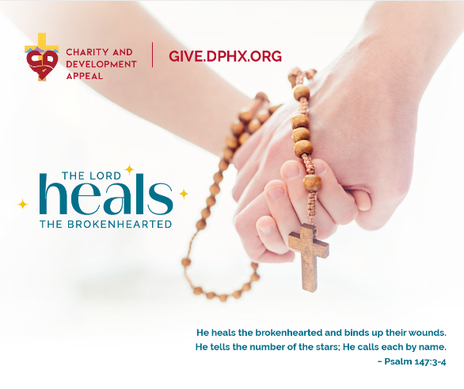
Throughout Scripture, Jesus reminds us that He came to heal the brokenhearted – each one of us. When we experience His life-changing love, we can’t help but go forth and share it with others! By supporting the Charity and Development Appeal, you partner with more than 70 ministries and charities to spread the hope and healing of Christ to every corner of our Diocese! Give today at www.give.dphx.org #CDA24

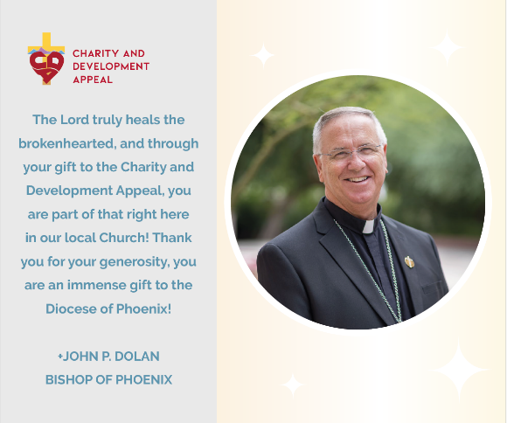

Ultrasounds, warm meals for the hungry, Catholic education, and televised Mass for the homebound are a few of the many wonderful ministries you make possible through your gift to the Charity and Development Appeal. Thank you for being part of the CDA, a pillar of hope in the Diocese of Phoenix for more than 50 years! Give today at www.give.dphx.org #CDA24

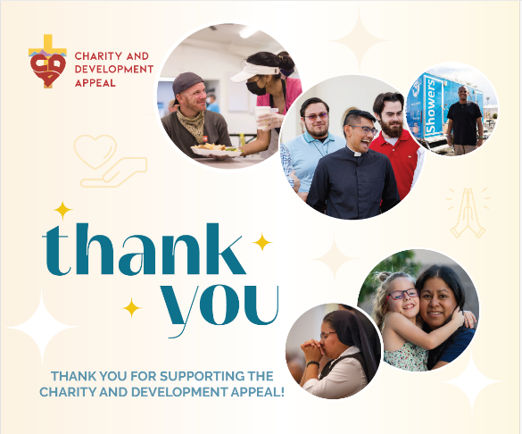

Thousands of individuals and families experience the hope and healing love of Christ through your gift to the Charity and Development Appeal! You make it possible for children in foster care to find loving homes, pregnant mothers to receive material items and accompaniment, and the incarcerated to be strengthened through Communion services and mentoring. Thank you for being the hands of Christ in the Diocese of Phoenix! #CDA24

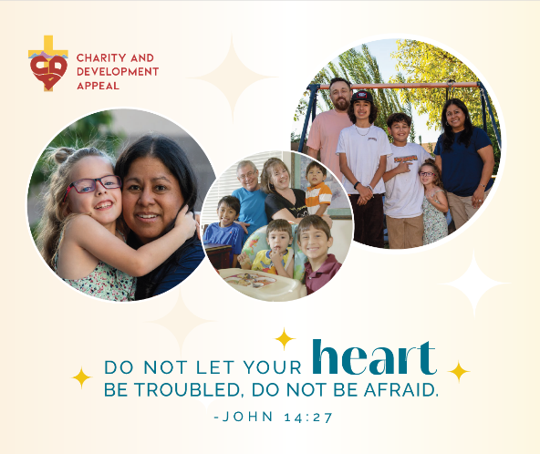

Thank you for supporting parents like Jason and Rebecca, who have provided a loving home for 21 children in foster care! Through your gift the Charity and Development Appeal, you support the Catholic Charities Foster Care Program, impacting children and families for generations. Give today at www.give.dphx.org #CDA24

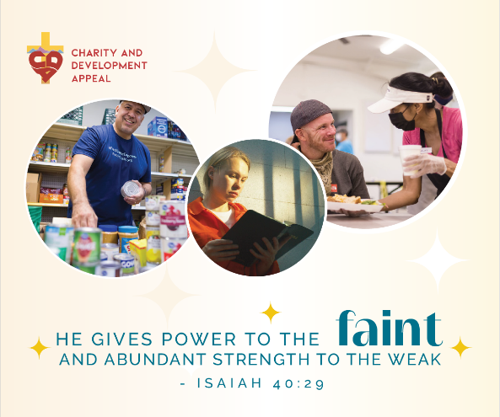

Through your gift through the Charity and Development Appeal, you support more than 70 ministries and charities throughout the Diocese of Phoenix – including Prison Ministry. Because of you, 50 Communion Services take place weekly in 21 jails and prisons, accompanying our incarcerated brothers and sisters. Thank you for bringing the hope of Christ to so many! Give today at www.give.dphx.org #CDA24

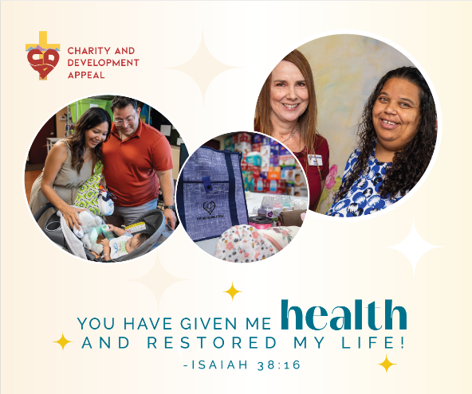

Your support of the Charity and Development Appeal ensures that hundreds of mothers and fathers are accompanied along their pregnancy journey at six pregnancy centers in the Diocese of Phoenix. Your generosity provides parenting classes, material items, and accompaniment every step of the way. Join the impact and give today at www.give.dphx.org #CDA24

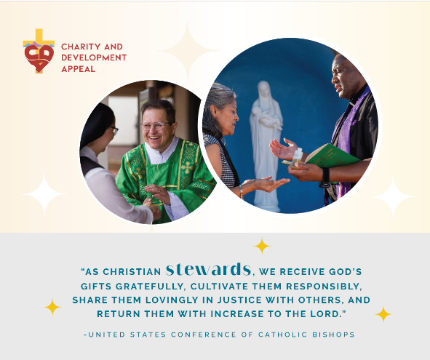

What gifts has the Lord given you? With more than 70 CDA-supported ministries and charities throughout the Diocese of Phoenix, these is a place for you to serve and bring the hope of Christ to others! Check out the many ministries supported by the CDA at https://dphx.org/cda/grants-and-allocations/ and see which one resonates with you! #CDA24

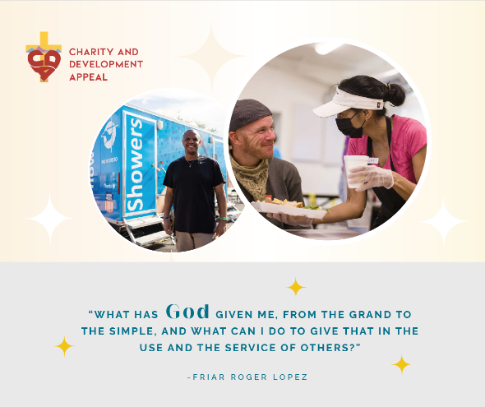

We all have time, unique talents, and treasures to share with others! The Lord calls us to be good stewards of what we have received, joyfully partnering with His grace to be His hands and feet in this world. Check out the many ministries supported by the CDA at https://dphx.org/cda/grants-and-allocations/ and see which one resonates with you! Volunteer your time, talent, and treasure today for a great cause! #CDA24

