Week 1: Kickoff Weekend, February 3-4, 2024
- In-Pew Envelopes and Pens should be placed in pew and replenished prior to all Masses.
- Place laminated QR Code Cards in pew for quick online giving
- Mass: Show the video, Pastor testimony or homily, Intercessions
  - Pastor’s endorsement of CDA is critical: Incorporate CDA into the homily.
  - English & Spanish Videos: https://dphx.org/cda/video-resources/
- Conduct true in-pew – Co-Chair(s) or volunteer
  - Walk parishioners through Ways to Give slides
  - Pull out cellphones and demonstrate QR Code Cards to give quickly online
- Bulletin: Publish Impact Insert, Bulletin Article below, or Bulletin Ads found online@
- https://dphx.org/cda/cda-parish-resources/
- https://dphx.org/cda/cda-parish-resources/bulletin-ads/
- Email and Social Media: Share the CDA Video, CDA Weekly Email or Flocknote, and social media posts available online: https://dphx.org/cda/cda-parish-resources/

Bulletin Article
Praise the Lord, who heals the brokenhearted. -Psalm 147
The Lord came into the world to draw us to Himself and to heal our broken hearts. When we experience Christ’s life-changing healing, we can’t help but go forth and share His love with others! Through the Charity and Development Appeal (CDA), you directly support our brothers and sisters in need through more than 70 ministries and charities in the Diocese of Phoenix. Share Christ’s love with your gift today! give.dphx.org

Intercessions
For the success of our Charity & Development Appeal, that the people of our parish will see the Appeal as an opportunity to bring hope and healing to those beyond our walls in the local community. We pray to the Lord…
Bulletin & Digital Media Materials
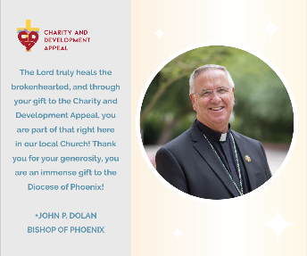
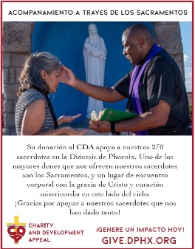
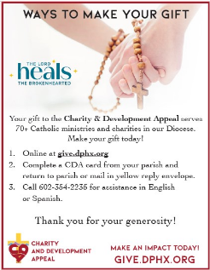

CDA Envelopes Bulletin Ad Bulletin Ad Digital Media

How to Conduct In-Pew Process on
Kickoff Weekend February 3-4, 2024

- Show the CDA Video
  - English & Spanish Videos: https://dphx.org/cda/video-resources/
- Pastor gives homily incorporating CDA message.
- CDA Co-Chair(s) or Volunteer can lead the directions to make a CDA gift
  - Walk through the Ways to Give slides
  - Show people the CDA Envelopes placed in their pews
  - Have people pull out cellphones and use In-Pew QR Code Card to give online
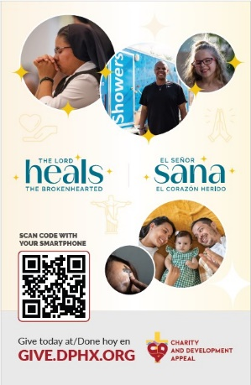
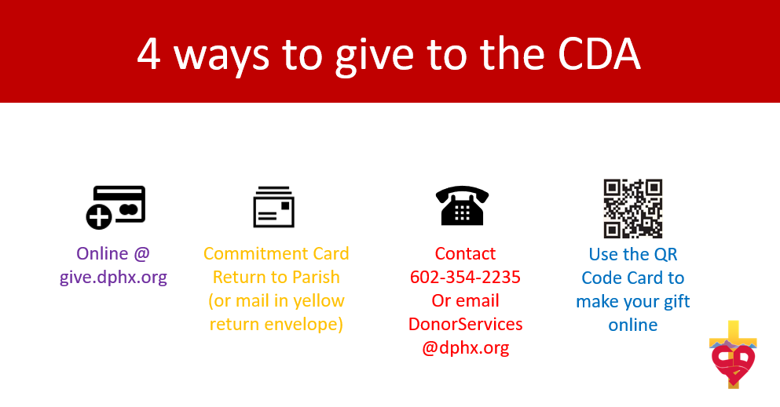
- Walk people through each option with the powerpoint slides.
- Encourage people to pull out their cell phone that day to give online using QR Code.
- Show a CDA sheet and yellow envelope inside parish CDA envelope. Mail or return to parish.
In-Pew Cards
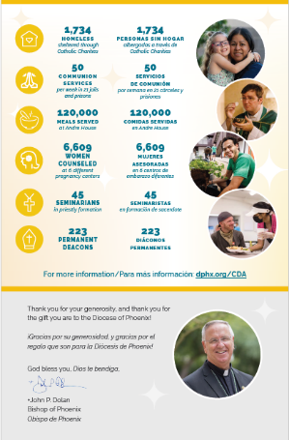
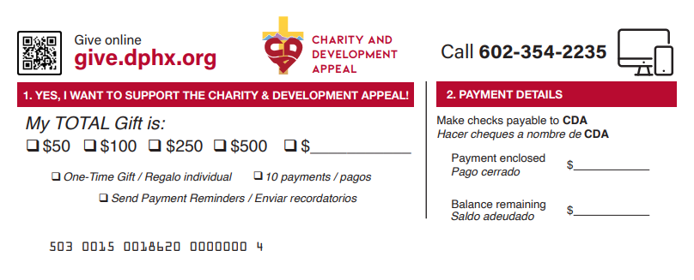
QR Code Cards (in-pew)
